/tmp/lo/0000.doc: 08/11/26

Modelling incoming Potential Radiation on a land surface
with PCRaster: POTRAD5.MOD manual

Drs. Oscar van Dam,
Utrecht Centre for Environment and Landscape dynamics
Utrecht University, the Netherlands
© POTRAD5.MOD Version 5, June 2000
http://www.geog.uu.nl/fg/ovandam/potrad/potrad.htm
E-mail: O.vanDam@geog.uu.nl

Contents
Introduction
Solar geometry & Solar radiation
POTRAD versions
Output examples
Literature

Introduction
Many processes on land surfaces are influenced by the amount of solar energy that is intercepted on the surface. In environmental modelling, like evapotranspiration models, incoming radiation is needed as input. Until recently it was not possible to calculate incoming radiation on a land surface, given by a Digital Elevation Model, in PCRaster (PCRaster, 1996). A new function HORIZONTAN was made, with which it is possible to calculate incoming radiation. This report describes the theoretical background for calculating the solar radiation on land surfaces and explains the PCRaster script POTRAD5.MOD in detail. The new function HORIZONTAN is explained. The model calculates incoming potential radiation as flux on a given time step (in W.m-²) and daily, monthly or yearly total energy (in MJ.m⁻².day⁻¹) on any surface. Daily radiation is the integral of calculated fluxes per time step. Optional, a correction per time step for cloudiness can be used or a fixed value can be given (default is 1, no clouds). The model requires a Digital Elevation Model as input as well as and the latitude of the study area. Additional information on solar geometry and radiation terms is reported in Radiation Time Plots (·.tss files), of which a map with sample locations must be present (this option can be turned off by erasing these command lines).

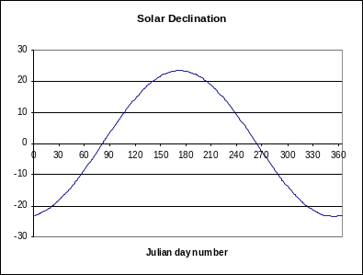
Solar geometry
Movement of the sun
Solar declination is the annual fluctuation of the sun between the two tropics and varies between –23 and +23 degrees latitude. Solar declination SolDec [deg] is calculated according to (Supitt et al., 1994):

SolDec = -23.4 · cos(360 · (Day + 10) / 365) (r

where Day [day] is the Julian day number.
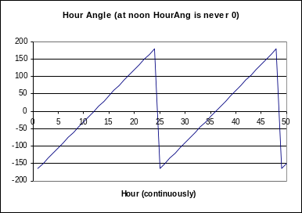
The hour angle describes the movement of the sun around the earth in 24 hours, which equals 15 degrees longitude per hour (360°/24h). The hour angle HourAng [deg] is given by:

HourAng = 15 · (Hour-12) (2)

Hour [hour] is the actual hour during a day.

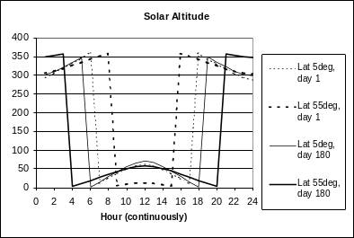
The position or height of the sun above the horizon is called the solar altitude or solar angle. Solar altitude SolAlt [deg] can be calculated for each location and moment during a year according to (Gates, 1980):

SolAlt = asin{sin(Lat) · sin(SolDec) + cos(Lat) ·
cos(SolDec) · cos(HourAng)} (3) (e

where Lat [deg] is the latitude of the area.

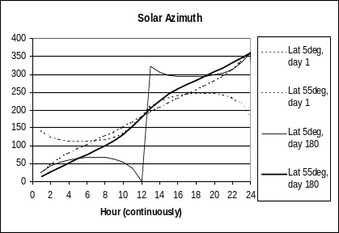
Solar azimuth
Solar azimuth is the angle between the solar beams and the North-South axes of the earth. Solar azimuth SolAzi [deg] is calculated with (Oke, 1987):

SolAzi = acos((sin(SolDec) · cos(Lat) - cos(SolDec) · sin(Lat) ·
cos(HourAng)) / cos(SolAlt))
For Hour ≤ 12: SolAzi = SolAzi
For Hour > 12: SolAzi = 360 – SolAzi (4)
Solar azimuth is set to 90 if 89.994 < SolAzi < 90 and is set to 270 if 269.994 < SolAzi < 270. (pers. comm. R.Sluiter, Aug '99).

Surface azimuth or aspect and slope
Surface azimuth is the orientation of the surface of the area to the North-South axes of the sun. It is calculated with the PCRaster function ASPECT to give AspMap [deg]. The slope of the area is calculated with the PCRaster function SLOPE, of which the arctangent is calculated to give SlopMap [deg]. Both Slope and Aspect maps should not be exactly zero.

Critical angle of the sun
To determine whether a cell receives direct radiation, a critical angle for each cell is calculated. When the solar angle is larger then the critical angle, the cell receives direct solar radiation. A new PCRaster function called HORIZONTAN calculates the maximum tangent of the angles of neighbouring cells in the direction of the sun (the solar azimuth) CritSun. A map is created (Shade) in which the cells are assigned 1 when SolAlt [deg] is greater then CritSun [deg] and 0 when not. Negative tangents are set to 0. Shade also becomes 0 when SolAlt is greater then 90 deg, e.g. when then sun is below the horizon. The syntax of the function HORIZONTAN is:

NewMap = HORIZONTAN(DEM,Direction)
NewMap is of type scalar, DEM is of type scalar, Direction is of type directional.
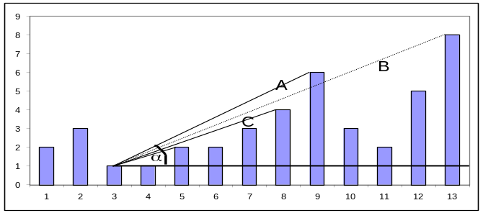
Since the function can only be executed if there are neighbouring cells, no value can be given to cells at the edge of the DEM map. They become missing values. Make sure that your DEM map is large enough and no crucial information is located in the edge cells. In the figure the tangent of angle α of cell 9 (A) is written down, although cell 13 (B) has a higher value.

There are two methods of using horizontan in POTRAD5.MOD. They can be used on either a static DEM or a dynamic DEM: a DEM which changes in time. The static DEM has the horizontan statements in the initial section of the script. This will slow down the initial calculations but speeds up the calculation of the remaining time steps. Horizontan is calculated for 5° (vs. 51) or 10° (vs. 52) intervals, which decreases the accuracy somewhat. For a dynamic DEM, the horizontan calculations have to be made in the dynamic section (vs. 50). Horizontan is calculated for the exact angle, which increases the accuracy. More details in the last part of this document.

Incidence of the solar beams on the surface
The angle of incident is the angle between of the incoming solar beams and the aspect and slope of the surface. It is used to correct the incoming solar flux for the surface area on which these solar beams are projected. The angle itself is not calculated, but only the cosine of the angle of incident cosIncidence [-], which is used directly to correct the solar flux normal to the beam. The cosine of the angle of incidence is calculated according to (Campbell, 1981):

cosIncident = cos(SolAlt) · sin(SlopMap) · cos(SolAzi-AspMap) +
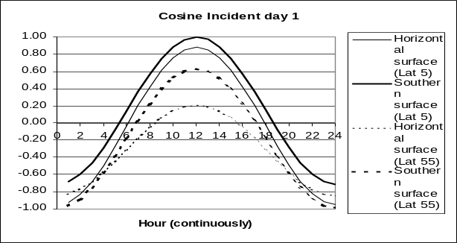
sin(SolAlt) · cos(SlopMap) (
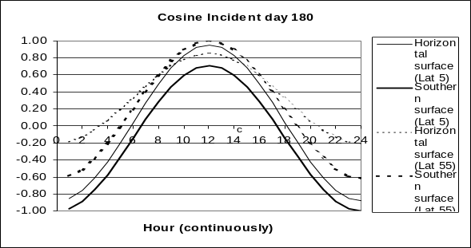

Solar radiation
Radiation outer atmosphere
Solar radiation Sout [W.m⁻²] that reach the outer layer of the atmosphere is calculated with (Kreider & Kreith, 1975):

Sout = Sc · (1 + 0.034 · cos(360 · Day/365)) (

Where Sc [W.m⁻²] is the solar constant of 1367 W.m⁻² (Duffie and Beckman, 1991). The radiation, which reaches the earth surface normal to the beam, is decreased due to the amount of air it has to pass through and the transmissivity Trans [-] of the air at the location of the study area. The radiation normal to the beam Snor [W.m⁻²] is given by (Gates, 1980):

Snor = Sout · Trans^{Mh} (

In which Mh [-] is the relative path length of the optical air mass at altitude h [m]. Transmissivity is usually between 0.5 and 0.8, but can be as low as 0.4 in the tropics (Whitmore et al., 1993). A value of 0.6 is commonly used (Jetten, 1994; Whitmore et al., 1993). To calculate the relative path length of an optical air mass at altitude h, the relative path length of optical air mass at sea level M0 [-] is corrected for the atmospheric pressure at altitude h. Thus Mh is calculated with (Kreider & Kreith, 1975):

Mh = M0 · AtmPcor (

The relative path length of the optical air mass at sea level M0 [-] is calculated according to (Kreider & Kreith, 1975):

M0 = √{1229 + (614 · sin(SolAlt))² } – 614 · sin(SolAlt) (

And the atmospheric pressure correction AtmPcor [-] is given by (List, 1984):

AtmPcor = ((288 - 0.0065 · Map)/288)^{5.256} (

Radiation at earth surface
To calculate direct radiation on the earth’s surface, the incoming radiation normal to the beam Snor must be corrected by the orientation and slope of the surface cosIncident. To calculate the actual radiation energy a correction for cloud cover Cloud [-] can be taken into account (default 1, no clouds). Only those cells, which are not in the shade of neighbouring cells, receive direct sunlight Sdir [W.m⁻²], which was given by Shade (1: no shade, 0 shade). Direct radiation is now given by :

Sdir = Snor · cosIncident · Shade · Cloud (

Indirect or diffuse sunlight is calculated for each solar altitude. When the sun is above the horizon it is assumed that all cells receive the same amount of diffuse radiation, corrected for their altitude. Diffuse radiation Sdiff [W.m⁻²] is calculated according to:

Sdiff = Sout · (0.271-0.294 · Trans^{Mh}) · sin(SolAlt) (

Total incoming radiation Stot [W.m⁻²] is calculated with:

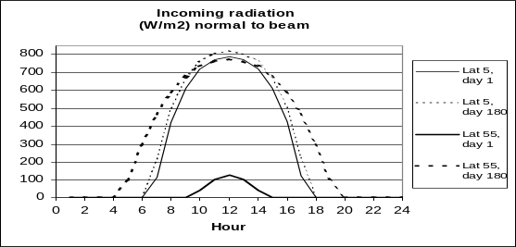
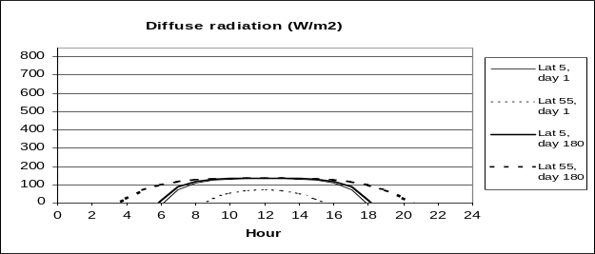
Stot = Sdir + Sdiff (

Day, month and year radiation
Total hourly radiation energy is the integral of total incoming radiation of one hour. Total hourly radiation energy per interval RadInterval [MJ.m⁻².interval] is calculated with:

PotRad = ((Sold + Stot)/2 · 3600) / 1000000 (

Where Sold [W.m⁻²] is the previous calculation of total incoming radiation Stot and Stot is the current one. It is multiplied by 60 seconds and 60 minutes and divided by 1000000 to give smaller values (MJoules). Total daily radiance PRadD [MJ.m⁻².d] is the sum of the hourly radiation intervals:

PRadD = Σ(PotRad) (

Month and Year sums are the equivalent sum of the day sums. Two Month sums are incorporated: Actual monthly sums: PradM*.* and 30 days total PradMD*.*. The actual monthly sums give the month sums at exactly the last time step in a month and this can only be used when HourStep and DayStep is 1 and likewise the total number of time steps in one year is 8760. When using another combination of DayStep and/or HourStep, PradMD must be used, which gives the radiation sum of 30 days. The total number of time steps in one year for a number of HourStep/DayStep combinations is given in the left hand side of Table 1. The middle section of Table 1 gives the total number of time steps per 30 days interval that must be filled in the timer section. The right hand side of Table 1 gives an overview of the year sum of radiation, as calculated with the DayStep/HourStep combination for an unobstructed grid-cell at latitude 52° N, which gives an indication for the accuracy of the combination.

The combination of HourStep and DayStep that gives the smallest amount of time steps in one year, 4 hours and 30 days = 73 ts, is 96.9% of the radiation as calculated with one hour and one day. It is better to skip days than to skip hours. With a DayStep of 10 days, radiation is still 100%.

Table 1 : No. of time steps in one year for a number of DayStep – HourStep combinations, the corresponding 30 days time step and the result of the YearSum.

 | Total no. of Time Steps |  |  |  | No. of time steps for 30 days report |  |  |  | Year radiation sum (MJ.m⁻²)
 | Hour step |  |  |  | Hour step |  |  |  | Hour step
Day Step | 1 | 2 | 3 | 4 | 1 | 2 | 3 | 4 | 1 | 2 | 3 | 4
1 | 8760 | 4380 | 2920 | 2190 | 720 | 360 | 240 | 180 | 4774 | 4718 | 4677 | 4645
2 | 4380 | 2190 | 1460 | 1095 | 360 | 180 | 120 | 90 | 4774
3 | 2920 | 1460 |  | 730 | 240 | 120 |  | 60 | 4776
4 | 2190 | 1095 | 730 |  | 180 | 90 | 60 |  | 4772
5 | 1752 | 876 | 584 | 438 | 144 | 72 | 48 | 36 | 4774
6 | 1460 | 730 |  | 365 | 120 | 60 |  | 30
8 | 1095 |  | 365 |  | 90 |  | 30
10 | 876 | 438 | 292 | 219 | 72 | 36 | 24 | 18 | 4774 |  | 4680
12 | 730 | 365 |  |  | 60 | 30
15 | 584 | 292 |  | 146 | 48 | 24 |  | 12
20 | 438 | 219 | 146 |  | 36 | 18 | 12 |  | 4764
24 | 365 |  |  |  | 30
30 | 292 | 146 |  | 73 | 24 | 12 |  | 6 | 4765 |  |  | 4627

POTRAD5 versions
There are 7 versions of POTRAD5. The versions are different for the latitude of the study area and the number of HORIZONTAN calculation that have to be made. These versions should be used for very large maps (over 200 by 200 cells). POTRAD v51 and v52 calculate HORIZONTAN in the initial part of the script, either for 5° azimuth intervals (vs. 51) or 10° intervals (vs. 52), whereby vs. 52 is faster than vs. 51, but also less accurate. The initialisation of the program can take several minutes, depending on the total number of cells in the map. Version 5 has to be used in studies where the DEM changes over time, since this version calculates HORIZONTAN for each new time step. The other version can only be used in a static topography. Table 2 gives an overview the differences between the versions. A total year of 860 time steps on a test map of 200*200 cells lasted almost 22 hours for vs5, less than 3 hours for vs51 and less than 2 hours for vs52 on a Pentium-II 330MHZ with 64MB RAM. Although vs51 and vs52 are considerably faster, their output of the year sum of radiation is considerably different for vs50, for unknown reasons. This will be studied in the near future.

Table 2: POTRAD5 versions

Name | LAT | HORIZONTAN
POTRAD5 | all: 90 <-> -90 deg | every possible one: 0-360 deg
POTRAD51 | all: 90 <-> -90 deg | 5 deg interval: calc. of #3 (#8) valid for #0-#5 (#5-#0)
POTRAD52 | all: 90 <-> -90 deg | 10 deg interval: calc. of #5 valid for #0-#10 deg
RADN51 | North > 23 deg | 5 deg interval: calc. of #3 (#8) valid for #0-#5 (#5-#0)
RADN52 | North > 23 deg | 10 deg interval: calc. of #5 valid for #0-#10 deg
RADS51 | South < -23 deg | 5 deg interval: calc. of #3 (#8) valid for #0-#5 (#5-#0)
RADS52 | South < -23 deg | 10 deg interval: calc. of #5 valid for #0-#10 deg

Output examples of the different versions are given in the "Examples" section. At the moment (July 2000) the difference between vs 5 and vs 51/vs 52 are unacceptable large for unknown reasons. Updates can be expected in the near future.

Output examples

Differences between v50, v51 and v52

v50: 200 by 200 cells, lat 52 deg, year sum radiation | v51: 200 by 200 cells, lat 52 deg, year sum radiation | v52: 200 by 200 cells, lat 52 deg, year sum radiation
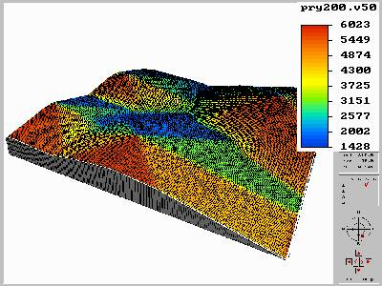 | 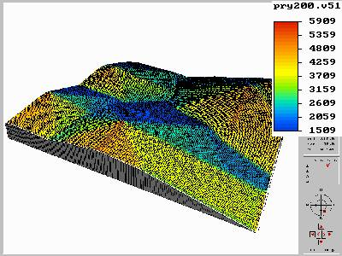 | 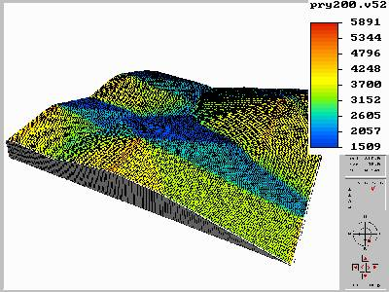
Difference v50 & v51 | Difference v50 & v52 | Difference v51 & v52
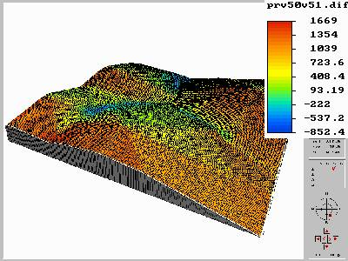 | 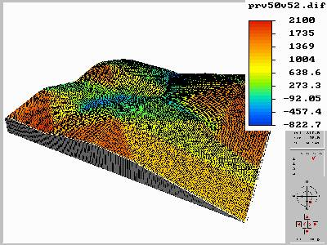 | 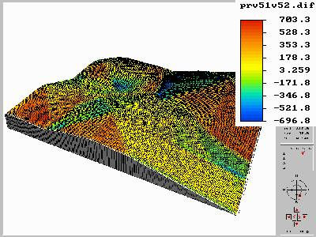

PCRaster can be found at: http://www.geog.uu.nl/pcraster.htm

Literature

Campbell, G.S. 1981 Fundamentals of radiation and temperature relations. In: O.L. Lange, P.S. Nobel, C.B. Osmond and H. Ziegler, Physiological plant ecology I: Responces to the physical environment. Encyclopedia of plant physiology 12A. Springer New York, pp. 11-40.
Duffie, J.A. and W.A. Beckman 1991 Solar engineering of thermal processes. John Wiley & Sons.
Gates, D.M. 1980 Biophisical ecology. Springer verlag, New York.
Jetten, V.G. 1994 SOAP SOil Atmosphere Plant model A one dimensional water balance model for a forest environment (Theoretical framework & Manual vs. 2) Dept. of Physical Geography, Utrecht University, the Netherlands. The Tropenbos-Guyana Programme, Georgetown, Guyana.
Kreider, J.F. and F. Kreith 1975 Solar heeting and cooling. engineering, practical design and economics. Scripta Book Comp.
List, R.J. 1984 Smithsonian Meteorological Tables. 6th rev version Smith inst press Washingtom
Oke, T.R. 1987 Boundary layer climates. Methuen, sec. ed.

PCRaster, 1996 PCRaster Version 2 Manual. Department of Physical Geography, Utrecht University.
Supit, I., A.A. Hooijer and C.A. van Diepen 1994 System description of the WOFOST 6.0 crop simulation model implementation in CGMS Vol 1. Theory and algorithms. Joint Research Centre, Ispra, Italy.
Whitmore, T.C., N.D. Brown, M.D. Swaine, D. Kennedy, C.I. Goodwin-Bailey and W.-K. Gong 1993 Use of Hemispherical photographs in forest ecology: measurement of gap size and radiation totals in a Bornean tropical rain forest. J. of Trop. Ecol. 9:131-151.

NOTE: This is a shareware program for PCRaster. Refer to this document for citation.
Do not distribute without prior approval of the author.

